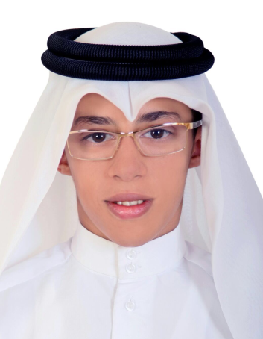**Curriculum Vitae**

**ALI HASSAN FATEEL HASSAN ABDULLA**

**Email: alooy.trsimo@gmail.com**

**Cell : +973 34090508 _ 37176797**

|  |
| --- |
|  |

**PERSONAL DETAILS**

Marital status : Non

Date of birth : 23/11/1999

Nationality : Bahraini

Address : House 492, Road 613, Block 406, Sanabis

**EDUCATION DETAILS**

2014-2017 Al - Jabriya Secondary Industrial School

**SKILLS**

-Training in Al Riffa Power Station (EDD)

YOURS TRULY,

ALI HASSAN FATEEL